***Bus Route Identifier using Google Map***

***Abstract* The objective of the report was to offer a technology-based solution to bus route identifier, which is a major problem in our daily life. The proposed approach offers a system as a solution which can be used to identify bus route. Data were collected from survey about many aspect of bus route identifier. The findings demonstrated that the proposed solution is capable of addressing and solving the problem. This can contribute to prevent bus route identifier and save time to people. Some suggestions were included to solve the issue. The future scope of the solution can be extended by using more advanced system.**

**Index Terms – Bus route identifier, road, bus, traffic, google map**

**I. Introduction**

**A. Background Information**

Bangladesh is a populated country. Specially its capital Dhaka is very much populated. The biggest problem of Dhaka people is traffic jam & bus route identifier. People of all around the country comes here for higher study, admission coaching and to get job in higher company. But people of all ages faces problem for identifying the right bus for their destination. As a result, they lost their valuable time and late in their destination.

**B. Overview**

The study shows the importance of implementing bus route identifier system using google map. Bus route identifier is a app based system where a person can find the exact route of their destination. It will also help the person to select the correct bus for his destination. It will be one of the most important thing for saving people’s valuable time. The report focuses on the importance of introducing new technology and how it can play a big role in people’s life.

**II. METHODS**

1. **Description of the solution**

Challenges are faced while finding the correct bus route in the streets of Bangladesh. People from all around the country is come here for a better future. But their valuable time is wasted by the traffic & wrong route selection. To minimize the route identifier problem an application based system known as “Bus Route Identifier “should be introduced. This system will give the user shortest route and the correct bus of his destination.

1. **Methods Used**

A questionnaire-based survey on bus route identifier problem in Bangladesh was conducted among 24 people like student, office staff etc. Google form was used to prepare the questionnaire and as a medium to distribute it. 10 question were created and distributed to the participants. They were given a flexible deadline for submitting. Response were taken from April 1 to April 7 of the year 2021.

1. **Rationale of selecting participants**

People of all ages who travels bus most of the time were chosen for the survey because they are up to date with the technology. This group was given priority for their availability and quick response on the internet. They were selected individually via texting.

III. **RESULTS AND DISCUSSION**

1. **RESULT**

It could be observed from figure 1 that almost 70% of the people travels bus regularly more than once. More than 80% people travels bus regularly for at least once.

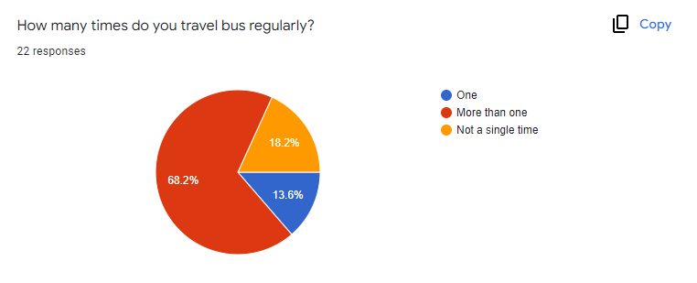

From figure 2 we can observe that more than 70% people finds difficulty in identifying bus route. Only 27%-28% people finds it easier to identity bus route

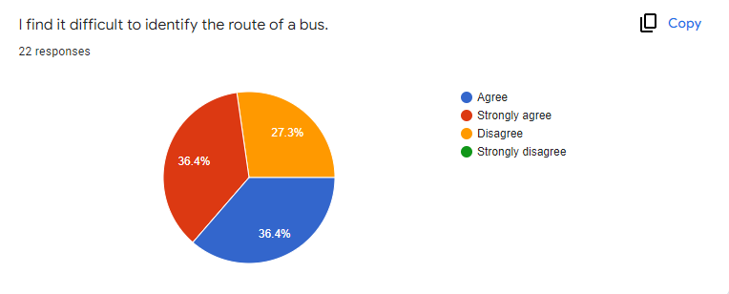

Figure 3 illustrates that almost 70% of people have traveled once or more than once in bus for 30 days straight.

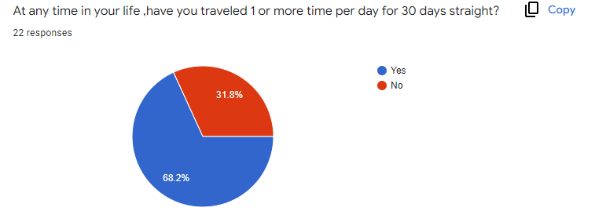

Figure 4 shows that almost 95% people are late in work for choosing long route bus.

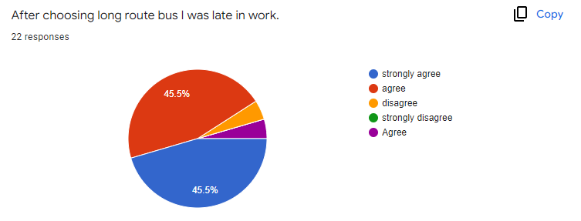

Figure 5 shows us that almost 7 persons of every 10 person face problem in identifying bus route.

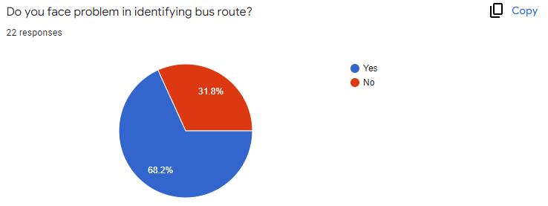

Figure 6 illustrates that almost 70% people face problem in identifying correct bus for their destination

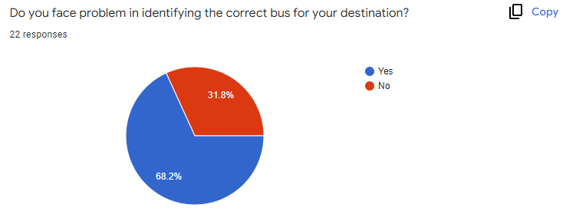

**B. DISCUSSION**

From the data in the result section, it can be said that the solution of the problem of bus route identifier is going to minimize if the “Bus Route Identifier “ system is introduced. One of the major findings is how hard it is for people to find correct bus. Almost 90% people are late in their work for choosing wrong bus or wrong bus route.

As most of the respondents agreed on implementation of “Bus Route Identifier “ system, it suggests that this system will save a lot of valuable time for the people.

**IV.CONCLUSION**

To conclude, bus route identifier is a major problem in Bangladesh. Many people lost their valuable time which are permanent due to this issue. One solution is not enough to prevent it. If the system is used by people of all ages it will definitely create an impact. Also people have to be extra careful about choosing the right bus. Many times people are careless about choosing right bus while travelling. Awareness of people and proper implementation of the technology which are beneficial in reducing bus route identifier problem.

This research should be done in large scale and government organization should conduct a research on how this system can help in minimizing route bus route identifier problem.

**V.REFERENCES**

1. J. Blenkurn,” The latest in on demand transit,” page: underperforming Bus Routes,2022. Available online: https://www.rideco.com/blog-tag/underperforming-bus-routes?fbclid=IwAR2m34YABEp7AYEURN23Pr3GbQNYWO3yhlvthSXKiOBnw1m_6Rpocz2sPGs

2.A. Afsarul Haider, “Traffic jam,” The ugly side of Dhaka development, Para 3, May 13,2018. Online available: https://www.thedailystar.net/opinion/society/traffic-jam-the-ugly-side-dhakas-development-1575355?amp&fbclid=IwAR03RN3T381O-zJ6aGVpt-YCcPLNgbzg8n06bxueYnxyiJBLs4lv7iDj1Ew

3. H. Babakarkhail ,” Traffic congestion,” page: Cost estimation and value of time, 2018. Online

available: https://www.researchgate.net/?fbclid=IwAR04LxVKj_2MDEeDtNEygo0gUJrAoGSQSvK-01dntYHGbnzs0cBP3m6STgw

4. J. Campbell, school bus routing problem. [Microform]. Science direct & co., Canberra: Department of science and technology,2004.

**VI.ACKNOWLEDGEMENT**

I would like to sincerely thank my course instructor THEOTONIUS GOMES, faculty of AIUB for teaching us by sharing his valuable knowledge. Without his guidance it would not have been possible to complete the report. He had been a great support throughout the process and his enthusiasm helped us to learn not just about the report but the actual course. I am also grateful to everyone who had taken part in this survey. I appreciate the effort of each and every one has put in to complete the survey.

**VII.APPENDIX** 